App and Web servers

- Install nginx and run nginx on port number 81..

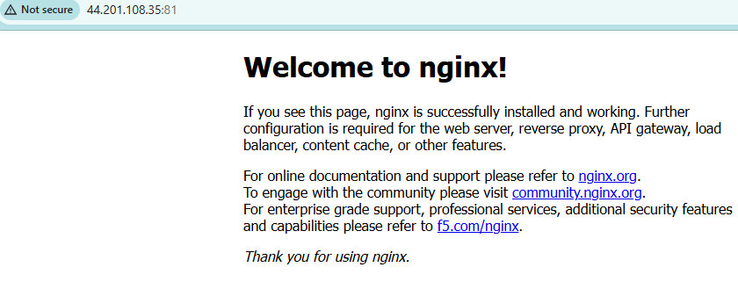

- Deploy a sample index.html file on nginx..

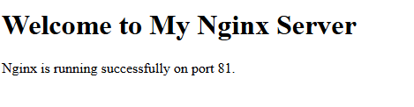

- Install Apache and run Apache on port number 82

- Deploy a sample index.html file on Apache..

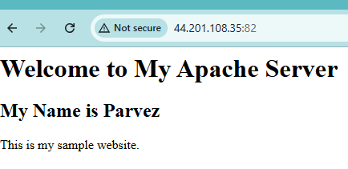

- Install Apache tomcat on port number 8082.
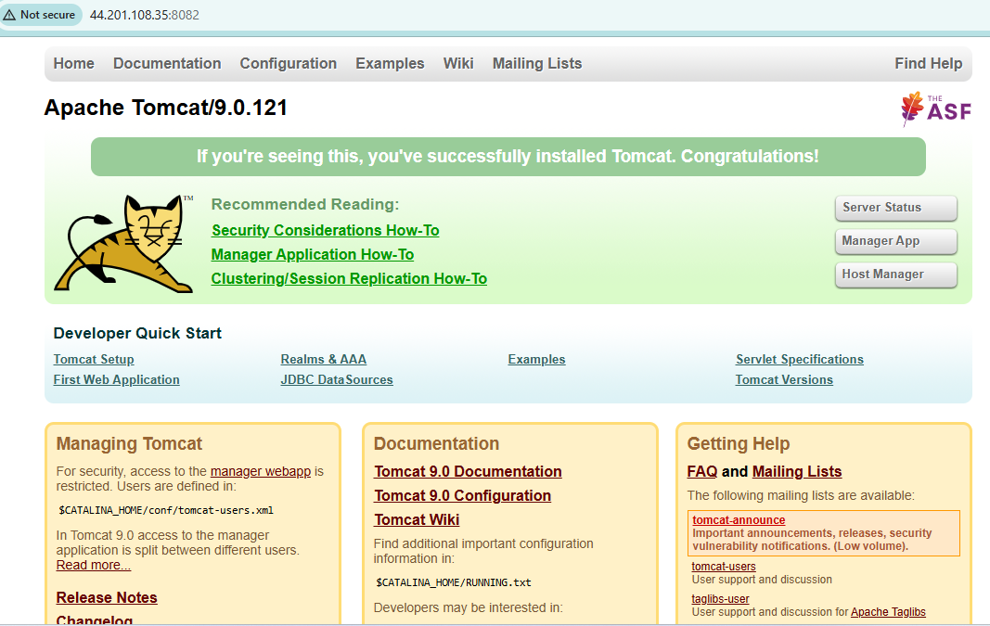

- Deploy a sample app on webapps.
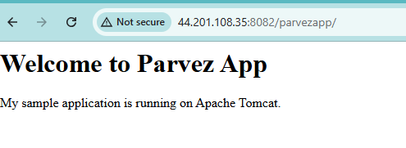

- Create a tomcat.service file for tomcat..

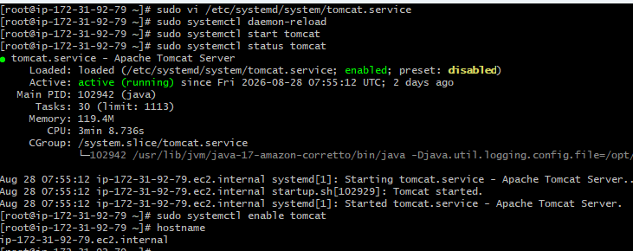

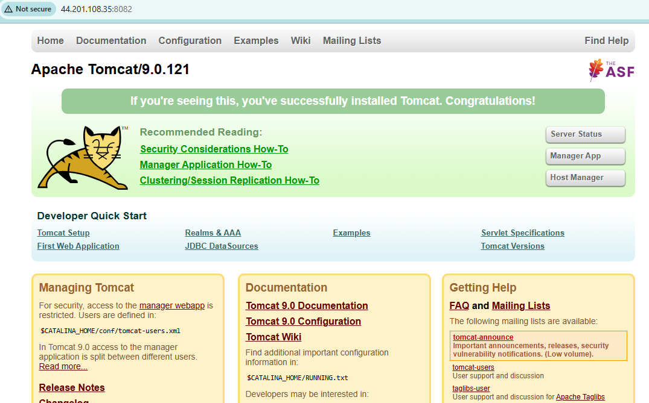

- Configure HA Proxy server. …

